Elucidation of Transporting Processes Times 14pt, bold, capital letters, centered, in upper and lower case, first letter capital

Tomáš Navrátil ¹, and Miroslav Fojta ²

¹ J. Heyrovský Institute of Physical Chemistry of the Czech Academy of Sciences, Dolejškova 3, 182 23 Prague 8, Czech Republic, E-mail: Tomas.Navratil@jh-inst.cas.cz
² Institute of Biophysics of the Czech Academy of Sciences, Královopolská 135, 612 65 Brno, Czech Republic

Text text text text text text text text text text text text text text text text text text text text text text text text text text text text text text text text text text text text text text text text text text text text text text text text text text text text text text text text text text text [1, 2]. text text text text text text text text text text text text text text text text text text text.
Text text text text text text text text text text text text text text text text text text text voltammetrically [3]. Text text text text text text text text text text text text text text text text text text text text text text text text.
Text text text text text text text text text text text text text text text text text text text voltammetrically [1-4]. Text text text text text text text text text text text text text text text text text text text text text text text text. Text text text text text text text text text text text text text text text text text text text text text text text text.
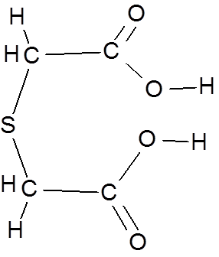
Fig. 1: Thiodiglycolic acid

References
[1] J. van der Geer, J.A.J. Hanraads, R.A. Lupton, The art of writing a scientific article, J. Sci. Commun. 163 (2010) 51–59. https://doi.org/10.1016/j.Sc.2010.00372.
[2] Van der Geer, J., Hanraads, J.A.J., Lupton, R.A., 2018. The art of writing a scientific article. Heliyon. 19, e00205. https://doi.org/10.1016/j.heliyon.2018.e00205.
[3] W. Strunk Jr., E.B. White, The Elements of Style, fourth ed., Longman, New York, 2000. [4] G.R. Mettam, L.B. Adams, How to prepare an electronic version of your article, in: B.S. Jones, R.Z. Smith (Eds.), Introduction to the Electronic Age, E-Publishing Inc., New York, 2009, pp. 281–304.
[5] Cancer Research UK, Cancer statistics reports for the UK. http://www.cancerresearchuk.org/ aboutcancer/statistics/cancerstatsreport/, 2003 (accessed 13 March 2003).
[6] M. Oguro, S. Imahiro, S. Saito, T. Nakashizuka, Mortality data for Japanese oak wilt disease and surrounding forest compositions, Mendeley Data, v1, 2015. https://doi.org/10.17632/ xwj98nb39r.1.

Acknowledgments
The research was supported by GA AV CR (project No. IAA400400806) and by GA CR (project No. P206/11/1638 and project No. P208/12/1645).

